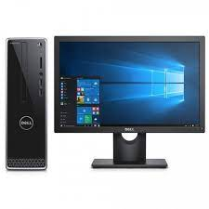

Dell Desktop

* Processor I5
* Operating System Window 10
* Hard Drive 500GB
* Memory Size (RAM) 4GB
* **Rs.70500**